AWS- Vinoth Selvaraj
Goal : to architect high available, scalable, reliable and secure cloud iinfra for containerized application on AWS.
Cloud Achitects :
- End user : performant/ responsive apps ensuring high availability and scalability.
- Hcker/Bad Actors : secure infra.
- Other Developers : streamline the development and deployment workflows.

Cloud Terminology:
- Region
- Availability Zone
- Edge Location
Region: where we create our resources like VM, LB etc. It is a geographical area. It has a min of 2 AZ.
AZ : A data centre contains of huge number of servers. We can deploy our app in diff AZ to make it available all the time if suppose there is a disaster happens at on AZ.
Edge location : suppose you app is deployed in Virginia, we have a lot of customers far from Virginia, because of the distance it will increase the latency. Edge location solves latency issue, which is a mini data centre which cache the content from the deployed data centre reducing the latency for the users.

Ec2 – elastic computing cloud :
- Resizable computing capacity.
- Launch a VM in a minute
  - OS/AMI(Amazon Machine Image)
  - CPU/Memory
- Scale up and down depending on requirements.
Ec2 – pricing model :
- On-demand : use it as long as u want. Pay/hour
- Reserved : reserve a VM for 1 year or 3 years.
- Dedicated : dedicated physical hardware in cloud.
- Spot : up to 90% discount(unused VMs in Data center, AWS might reclaim these instances any moment – with a 2 minute warning)
Create EC2 :
- Select a region (Virginia)
- Select OS
- CPU architecture
- Instance type : CPU and memory
- Create key – pair for login
- Network settings (Auto sign public IP – Enable)
- Security group – list of firewall group rules that we want to apply.
  - Inbound : 22 – ssh access
  - Source type is anywhere – from any where but requires key
- Disc storage
- We can also add volumes.
ARN : Amazon resource name****
SSH from local :
- Public IP and Private IP
- Windows users :
  - SSH putty : provide public IP, port 22. User name(ec2-user) and password.
- Linux user :
  - Chmod 400 vins.pem
  - Ssh -I vins.pem ec2-user@<ip address>
- EC2 instance connect:
  - Sudo yum install docker
  - Sudo systemctl start docker.service
  - Sudo docker version
  - Sudo docker run hello-world
Ngixx:
- Sudo docker run -p 80:80 nginx
  - Pull the image and starts the container.
- Now configure the firewall for 80 port in inbound rules.
  - HTTP -> 80 || source IP add : anywhere
- Now use the public ip of the instance on browser, we can see the Nginx home page.
Own AMI :
- Launch instance -> Amazon linux -> select key-pair -> we can use existing security group
- Instead of installing required software’s each time, we can just create an AMI with all the software’s so we can launch this AMI as an instance.
- Creating AMI : Actions -> image and templae -> create AMI
- Now AMI is available in AMI section.
Security groups :
- By default, all inbound requests are denied.
  - We have to explicit add the “allow” rules.
    - Port
    - Source
      - What if we don’t know the source IP/CIDR
      - IP add might not be reliable as it might change!
- No “deny” rules (once port is opened it is opened for all, and to restrict the usage from a particular IP should be handled in NACL).
- A security group can be attached to multiple Ec2 instances.
- An EC2 instance can be attached with multiple security group. No conflicts because it has only “allow” rules.
What if we don’t know the source IP/CIDR
IP add might not be reliable as it might change!
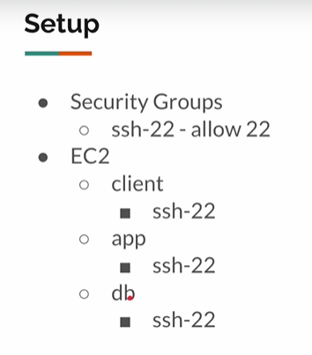
Db -> opens PostgreSQL port and we want to get request only from app.
- Security groups -> create SG “ssh-22” -> Inbound rules -> 22 || source anywhere 0.0.0.0/0
- Instance -> 3 EC2
  - Client
    - SG = “ssh-22”
    - SG= “client-sg”
  - App
    - SG=”ssh-22”
    - SG=”app-sg”
      - Inbound rules : 80 for client-sg
    - Connect->
      - Psql -h <private ip:DB> -U postgres
  - DB
    - SG=”ssh-22”
    - SG=”db-sg”
      - postgresSql
      - inbound rules -> source -> security group -> select the required SG “app-sg”.
    - Connect ->
      - docker run -p 5432:5432 -e POSTGRES_PASSWORD=password postgres
SG’s:
- ssh-22
- client-sg
- app-sg
- db-sg
Don’t edit same security group which can affect other instance making it as a security issue.
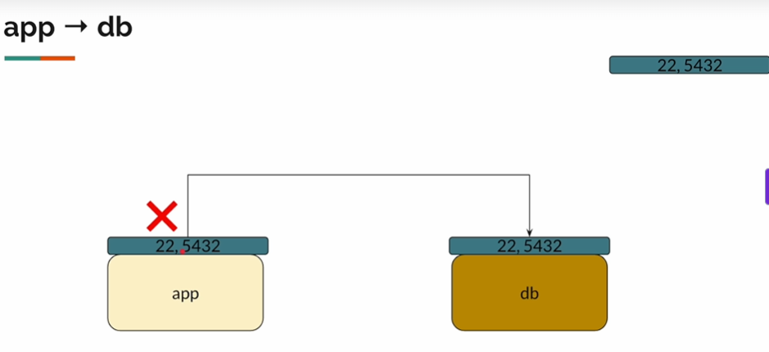
Create new security group and if we are not sure the source, from which instance we should allow access then we can attach the security group of the source instance to the DB security group.
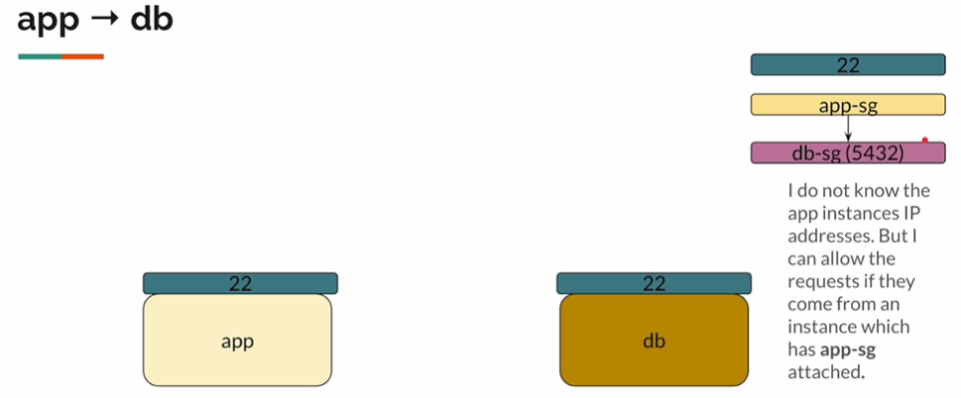

Configure db-sg SG to allow ay request coming from the instance that has the app-sg security group to allow postgrSQL.
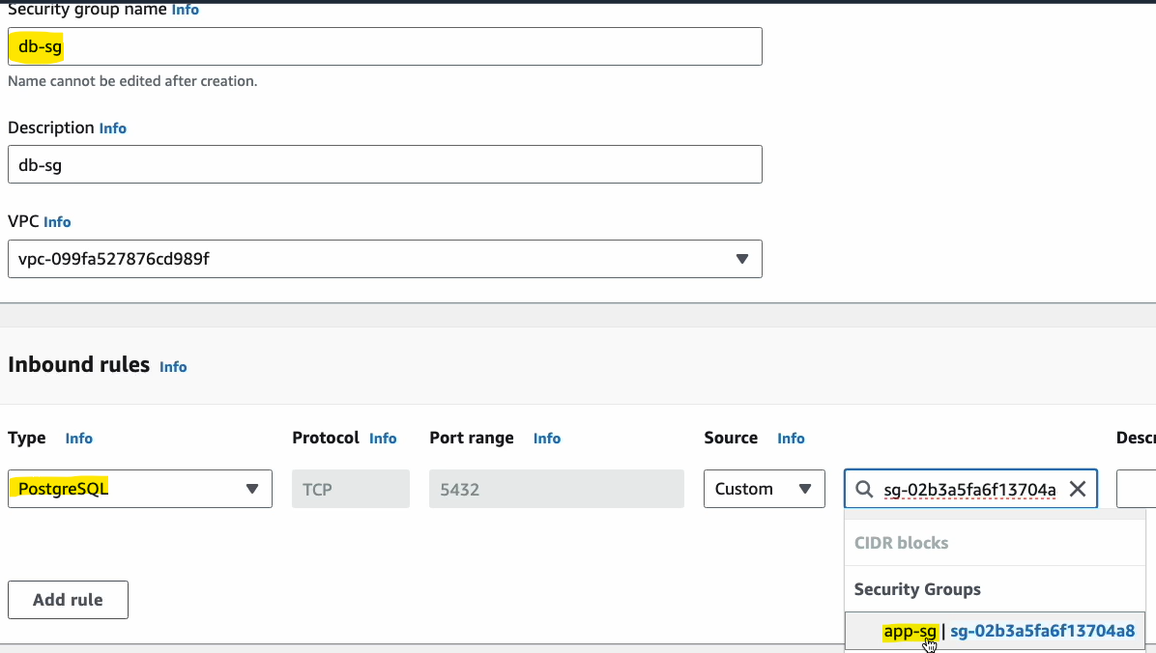

Self-referencing security group:
- Default SG : by default, all the traffic is allowed, all ports are opened. But source refers 1 SG which is its own ID.
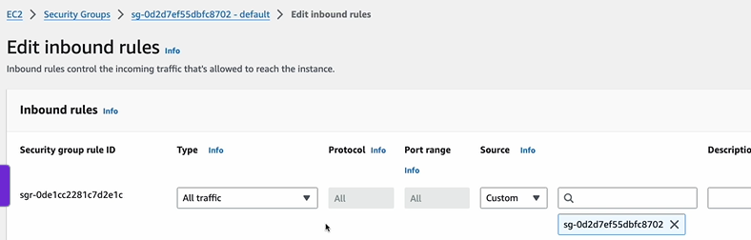
- In case of Microservice architecture, instead of creating multiple security groups, we can use same SG, and self-refer It like below image.(option)
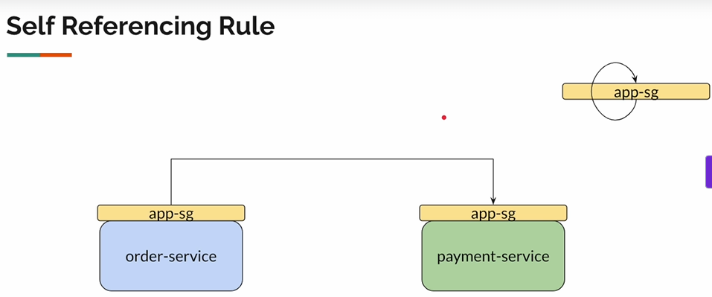
User data :
- Run some scripts as soon as the system runs.
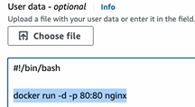

S3 – Simple Storage Service
- Secure, durable and Highly available Object storage.
- Object :
  - Any File(txt,csv,img,css,movie,mp3,zip,backup…)
- An object can be of 0 bytes to 5 TB
- Unlimited storage
  - Store N number of Objects
  - Pay/GB
    - Ther are various factors, but for some idea, ~0.02/GB/month.
S3 bucket:
- Globally unique directory
  - S3://vins
    - S3://vins/file1
    - S3://vins/file2
- Since its globally unique AWS provides urls like below
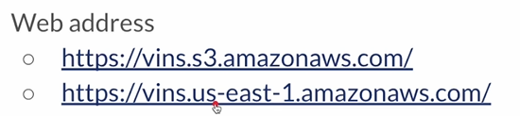

Creating S3 bucket:
- Create bucket -> general purpose -> vins-demo ->go with default options for now.
- Pre-signed url concept, no body should able to access this but want to share with someone. This will generate a temporary token that expires after some time. It will be same url but appended with security token.
S3 bucket policy :
- Bucket -> permission -> by default public access is blocked -> uncheck it.
  - It won’t let you access the files even after unchecking; to really access publicly we must provide a policy to the bucket.
- Bucket policy :
  - A set of permissions return in JSON, that we attach to s3 bucket.
    - Edit bucket policy -> paste the JSON
- Create policy :
  - Use policy generator :
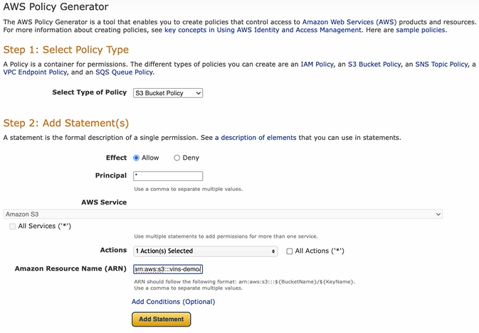
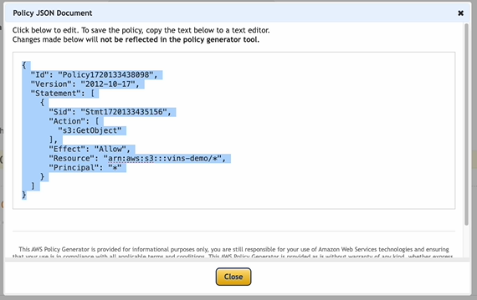

We want to restrict the JPG file, ad allow only PNG
- Edit bucket policy.
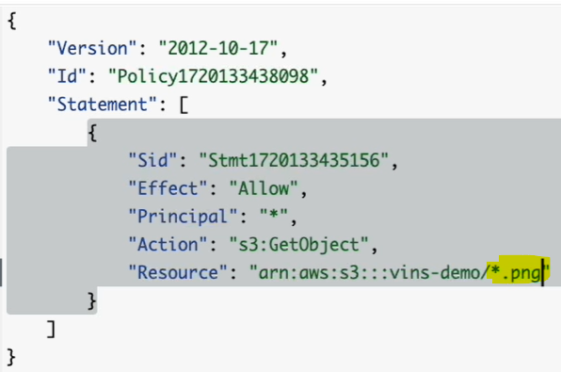
Note : we should maintain separate bucket for sensitive information.

